Resume

Name of Teaching Staff | Prof. Ashwini Walhekar |  |  | 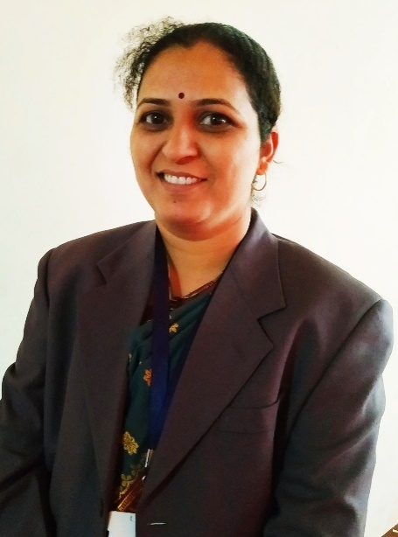
Institute Name | PDEA`S Mahatma Phule Institute of Management and Computer Studies, Hadapsar,Pune.
Designation | Assistant Professor
Department | MBA
Area of Specialization | Human Resource Management
Date of Joining the  Institute | 24/11/2011
Qualifications with Class/Grade | UG  (B. Com) | First Class | PG  (MPM) | First Class with Distinction
Total Experience in  Years | Teaching | 14 Yrs | Industry | 01 Year
Paper Published | National | 03 | International | 01
Books Published | NA

